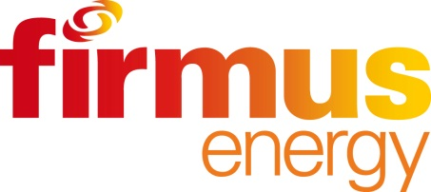
10 October 2014

Mount St Catherine’s Primary Buries Time Capsule
firmus energy helps school to capture the present for the future

Mount St Catherine’s Primary School, Armagh, recently invited Lord Mayor Cathy Rafferty along to help the pupils to bury a time capsule, containing information and items that will give the children of the future an idea of what life, community and the culture of the school was like in 2014.
Local natural gas company, firmus energy, who recently installed the fuel in the school, facilitated the project along with their contractor McNicholas Construction. Mount St Catherine’s principal, Mr Gildea explains: “Following a conversation between our vice principal and a member of the firmus energy team, this project came into fruition. The children and staff were very enthusiastic from the outset and collectively we decided what should be included that would represent ‘today’ for the ‘children of tomorrow’.

“We hope that what we have placed inside, such as a school jersey, photos of pupils, some of the children’s written work and their hopes and dreams for the future will provide Mount St Catherine’s pupils 50 years into the future with a unique insight into how life was for the children of 2014. It will hopefully reflect our times and what will have changed in the years in between.

“This was an important project for us and we were grateful to the Lord Mayor, firmus energy and McNicholas Construction for supporting us. The children were crucial and central to the whole process and we believe that it is important to instil a further sense of history and local community in them. The children all witnessed the items being added to the time capsule in the assembly hall and were present when it was buried in our grounds.

“They will see a plaque marking the burial site each and every day when they are in Mount St Catherine’s and one day, perhaps when their grandchildren may be attending the school, unearthing the time capsule will hopefully provide some wonderful memories for these former pupils, as well a fascinating look at the past for what will be the pupils of 2064.”

Mount St Catherine’s switched to natural gas from oil in the summer of 2014. Mr Gildea continues: “We have around 235 pupils and a staff of approximately 40 of which 12 are teachers. The School made the decision to convert to natural gas as it is economically advantageous and also more environmentally-friendly, which is important to us and we are working towards attaining the green flag status as the school already has ‘eco-school’ standing.

“We are also finding natural gas much more convenient as it is always available and we don’t need to remember to reorder. We use it to heat our school and also for cooking in our kitchens.”

Michael Scott, managing director of firmus energy commented: “firmus energy was delighted to be involved with this project. It was lovely to see the children’s excited faces as the time capsule was lowered into the ground. I hope that firmus energy will be invited along 50 years into the future when the time capsule is being unearthed!

“Natural gas is proving a popular fuel option for schools across the province, who, like all businesses and organisations, are extremely cost conscious. By converting to firmus energy, they will make significant savings on their fuel bill each and every month.”

Mike Caulfield, operations director for McNicholas Construction added: “It is great to be a part of history as we help firmus energy to bring natural gas to homes and businesses in more and more areas across the province. This project will help people to remember the time when this major infrastructure was new to the area and how life has changed in the years between now and 2064.”

Natural gas is available in Armagh and to find out if your home or business can be connected, visit www.firmusenergy.co.uk.

-ends-

For further information, please contact Suzie Fisher of dcp strategic communication, on 028 9037 0137.

